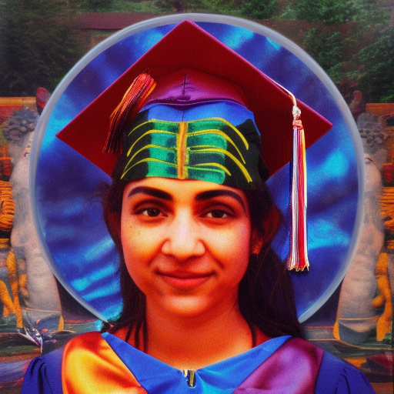
LAKSHMI’S PRISM

Graduation caps of Nefesh
The affliction of conceptual capacity
Always more, but no more than enough in mind
Caring for lovers pangs
The perils of wrongful collection
The joy of flesh a gnosis of skin
Ecstatic triumphs
Delusion & pride subdued in rest
Equanimity seated upon Lakshmi’s precious piles
Glimmering prisms of lively speech

